**OPTIMIZING SPAM FILTERING WITH MACHINE LEARNING**

INTRODUCTION

Overview

* In this project we know about how to filter and find the spam messages from the hacker. SMS Spam Message is one of the major issue in wireless communication. World, So tackle this problem it is needful to use a smarter technique which correctly identifies spam SMS.
* So we used use Natural language processing process to find spam and Non-Spam SMS.

Purpose

* Filtering spam messages
* Create Awareness about Spam Messages
* Protect users from unwanted or hamful messages

Problem Defnition & Design Thinking

Empathy Map

* In this empathy Map we include about what we understand about this project and how to solve it.
* What we does in this project and What we doesn’t

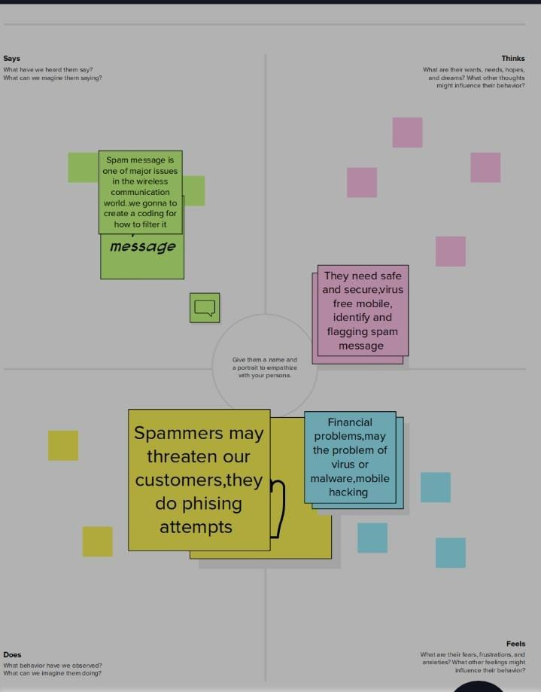

Result

Advantages & Disadvantages

Advantages:

* An email spam filter is a tool used in email hosting software that churns unsolicited unwanted.
* Protects the use from any potential cyber threat and facilitates smooth communications and workflow.

Disadvantages:

* People become nervous
* Data lost
* Phishing Scams and advanced fee fraud
* Withdraw money or steal personal detail

APPLICATIONS

* A spam filter is a program used to detect unsolicited, unwanted and virus-infected emails and prevent those messages from getting to a user’s inbox.
* Using android

CONCLUSION

* The entire message can be examined, not just special parts.
* So far, spam attacks on Bayesian filters have been relatively unsuccessful.

FUTURE SCOPE

* Spam detection is essential since it can ensure justice for the sellers and retain the trust of the buyer on the online stores.
* The algorithms developed so far have not been able to remove the requirement of manual checking .

APPENDIX